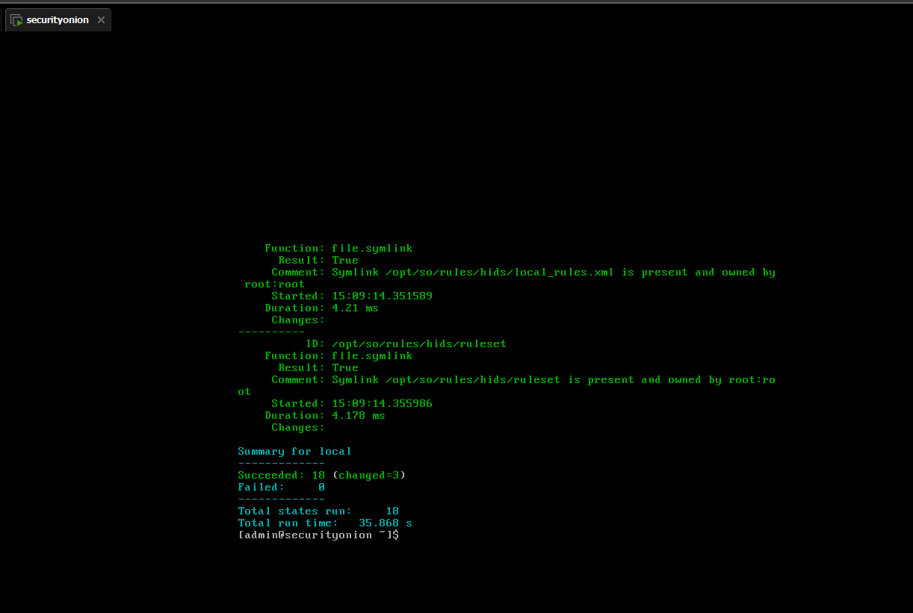

***Looking at the SO console what is Analyst and what is it used for?*** **Analysts is a role with a set of tools for data analysis, someone in an analyst role uses the tool set to investigate logs, alerts, and network traffic for threat detection.**

***Looking at the Chrome screen, what is CyberChef and what is it used for?* Cyberchef is a data manipulation web tool someone in this role analyzes logs, strings, encryption and transforms data.**

***Looking at the Chrome screen, what is Playbook and what is it used for?*** **Playbook is an incident response workflow manager. Someone in this role would use it to animate, document, and share the response process.**

***Looking at the Chrome screen, what is TheHive and what is it used for?*** **TheHive is an incident response and case management platform and is used to organize, investigate, and manage security incidents collectively.**